BLOGPOST - Serial CEO Gives 10 Tips For Successfully Managing Your Boardx

Serial CEO Gives 10 Tips For Successfully Managing Your Board
George Bell, General Catalyst Partners
ℑ
Nov. 5, 2014, 12:11 PM

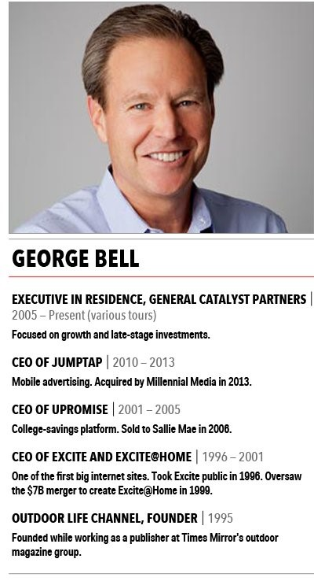
Mike Nudelman
So you got funded and you're the CEO – oddly terrifying, really, that you should be so unprepared for the biggest job of your life. Here's the crash course you didn't know you needed.
As CEO, the way you interact with your board members informs how they think of you as a leader, manager, and strategist. Yet most first-time CEOs run lousy board meetings, fail to set expectations with the board, and, worse, think of board gatherings as an obligatory penance for having raised money.
You don't want to invite board skepticism because of a sloppy process. Here's how to handle your board and board meetings:
Schedule board meetings way ahead of time.
For early-stage companies, schedule board meetings at two- to three-month intervals and for three hours. Get the meetings on your board's calendar one year in advance. Board members are busy, too. Unless you are shuttering or selling the company, last-minute requests for meetings drive them crazy.
Ask for your board's input.
Two weeks before a board meeting, send an email to the board with a proposed agenda of no more than five to six topics, and ask for their feedback. You will rarely get any, but you are creating transparency and openness with them, which is critical to a healthy dialogue — and your success.
Set expectations.
Board materials — decks, docs, whatever you want them to read — need to be in their inboxes three to five business days before the board meeting. Don't fire decks off last minute with the excuse that you were waiting for final figures, app downloads, or total number of granola bars consumed by employees last quarter.
A board meeting is not final; it is directional. Metrics that are a week or two old are fine, if it serves your ability to get the materials out on time. In your cover email, ask board members to read everything before the meeting. That way, you won't have to run through decks slide by slide.
Focus on your concerns.
Near the top of my board agenda, I lead with "What I Worry About," a single slide that summarizes my business anxieties. This does two things. First, it shows that you are focused on what can go wrong, since what goes right tends to take care of itself. Second, it brings the board members in on how you think about, and create context for, your business. (After you go public, this is a slide your lawyers will discourage you from writing, or at least want to rename.)
Often, we spend 20 to 30 minutes on this one slide. And then, of course, the deck materials (financials, product reviews, competitive threats) can be referred to, since everyone is expected to have already read them. You see where this is going? You are beginning to manage your board.
Give your lieutenants airtime.
During the board meeting, I like to have one to two presentations from senior team members on a critical initiative they've led. They will value the exposure to the board, and it's important for the board to see your team in action. It helps them evaluate the quality of their thinking, as well as the quality of your hiring. As a general rule, however, don't crowd the boardroom for too long.
Never invite consultants.
Only under penalty of death should you have consultants come in to present. The lease on a new building, 409a valuations, the status of your audit — cover that stuff in committees or by email. None of those topics will drive the business, so you are wasting valuable board time.
Don't whine.
When things are not going well, don't talk about how hard it has been on you or your team. They pay you a lot of money, or they think they do, and you have a big job. Suck it up. Cry to your barista, not to the board.


The first board meeting of Divide, a mobile device management service that was acquired by Google.Genecast
Allow time for questions.
Schedule 20 minutes for open discussion near the end, and excuse everyone except board members. Ask if the meeting hit the topics they thought were most important. Anything is fair game. Be open. Encourage them to speak their minds. Discourage back-channeling. Boards that require pre- and post-board powwows to discuss issues that they didn't want to bring up in the board meeting are already broken. Take notes on follow-ups, and summarize these briefly out loud.
Leave the room.
The final agenda item is always the same – 15 minutes for the board to discuss anything it wants in private. Without you. Leave them on their own. This way, you force them to create feedback. Maybe they all stampede to the elevator. Fine, that means they feel comfortable and have no issues with you or the business. Maybe one of them gets appointed to give you feedback. Great. You have set a tone. You expect them to discuss you and the business in an open and unencumbered way as a part of every board meeting.
Keep the dialogue alive between meetings.
Write a short note to the board every few weeks, or upon an important occasion, like a new hire, a key customer defection, or a piece of good or bad financial news. The tone is always of transparency and offering insights. Your VC board members sit on other boards. Small notices of your progress, or decline, are generally welcome.
Many of my past board members, such as Vinod Khosla or Bill Helman, believe that not much of importance gets accomplished in board meetings. You are unlikely to change their minds, so budget time for these discussions.
While some informal time with board members is a good idea, the quality of the board meetings and the dynamic of the discussion is yours to set. Generally I think of managing the board as equal to about one or one and half direct reports.
While the above should help guide the tone and architecture of your board relationships, it doesn't address the content of the meetings. What you choose to prioritize and review with your board in many ways reveals how you think about your business. In the end, that is more important than anything.
George Bell is a five-time CEO and an XIR at the Cambridge-based venture capital firm General Catalyst Partners.
See more in the series:
Yours To Lose: 9 Top Priorities For First-Time CEOs
Yours To Lose: 8 Rules For Creating An Annual Budget
Yours To Lose: 10 Rules For Hiring Exceptional Employees
Yours To Lose: 10 Rules For Firing Employees With Dignity
More: Management Yours To Lose CEOs Leadership ξ

Aus <http://www.businessinsider.com/ceo-guide-how-to-manage-your-board-2014-10>

